**BUG ID** #12345

**Description:** Incorrect value after the subtraction of the offer percentage to the initial value

**Product:** Philips Hue White 9W E27 Starter Kit

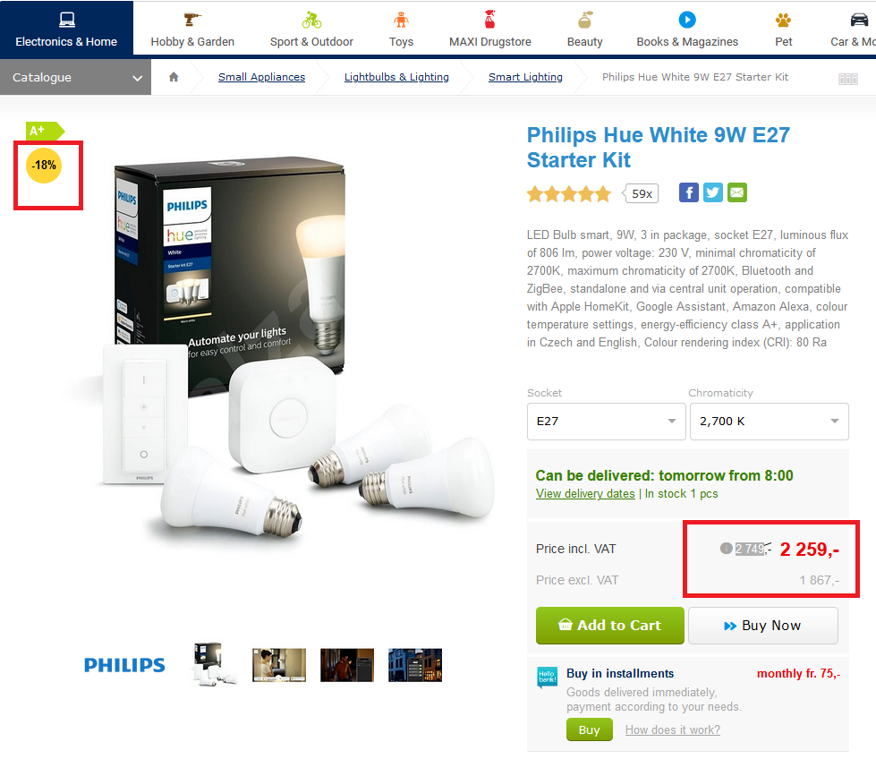

Percentage calculation on the initial value: 2476 * 0.18 = 494.82

Final price after subtraction of the percentage (18%): 2749 - 494.82 = 2.254.18

which is different with the price 2259 on the webpage